The Cotswold Way Challenge Race Instructions

Please find below all the information you will need to make your race weekend run as smooth as possible.

Start: The Scout Centre, Chipping Campden, GL55 6DG http://binged.it/ZjReio
Overnight: Cleeve School Sports Centre, Two Hedges Road, Bishops Cleeve, Cheltenham, GL52 8AE http://binged.it/ZjRlL1
Finish: Archway School, Paganhill, Stroud, GL5 4AX http://binged.it/XGIfRN
Locations
 |  | Day 1 | Day 2
Start | Post code | GL55 6DG | GL52 8AE
Start | Grid Ref | SP 151 391 | SO 963 268
Finish | Post code | GL52 8AE | GL5 4AX
Finish | Grid Ref | SO 963 268 | SO 836 058
CP 1 | Post code | WR12 7JZ | GL53 9NG
CP 1 | Grid Ref | SP083341 | SO969172
CP 2 | Post code | GL54 5AU | GL4 8JH
CP 2 | Grid Ref | SP059294 | SO893149
CP 3 | Post code | GL54 5AN | GL6 6ND
CP 3 | Grid Ref | SP014252 | SO850091

Timings

 | Day 1 | Day 2
Breakfast | N/A | 0600
Registration Open | 0700 | 0630
Walkers briefing | 0730 | 0645
Walkers Start | 0800 | 0700
Main Group Start | 0900 | 0800
Elite Briefing | 0930 | 0845
Elite Start | 1000 | 0900
Evening Meal | 1900 | N/A

Please note your Day 1 start time will be determined by the information you provide in your entry form. Subsequent days will be decided on your previous days finish time.

Registration

All competitors must register on day 1 arrival. At registration you will be given your race number, route card and map.

Getting to and from the Start

Parking
Parking is available at Registration. http://binged.it/ZjReio
Transportation:
Day 1 - pick up from Evesham Station and parking available at the start
Day 1 - pm - lift to Cheltenham station - 1 during the afternoon, plus 1 lift back to the start
Day 2 - am - option for pick up from Cheltenham Station
Day 2 - pm - regular drop offs to Stroud Station, 1 lift back to the day 1 start, maximum of 12 people. Small charge of £5 payable on the day.
Route Information

- This is a National Trail, the route is well marked, but you need to use your route card.
- You can view the route on our website by following the link from the event page.
- You will be given a route card with a description of the route and sections to be cautious.
- You can request GPS data from brian@xnrg.co.uk to load directly onto your GPS watch.

Checkpoints

Day 1 Start 9 miles CP1 6.2miles CP2 5.6miles CP3 6.5miles Finish
└────────────┴────────────┴───────────┴─────────────┘

Day 2 Start 9 miles CP1 9.7 miles CP2 5.8 miles CP3 6.9 miles Finish
└────────────┴────────────┴────────────┴───────────┘

Detailed information on distances, timing, ascent and descent, is on the next 2 pages.

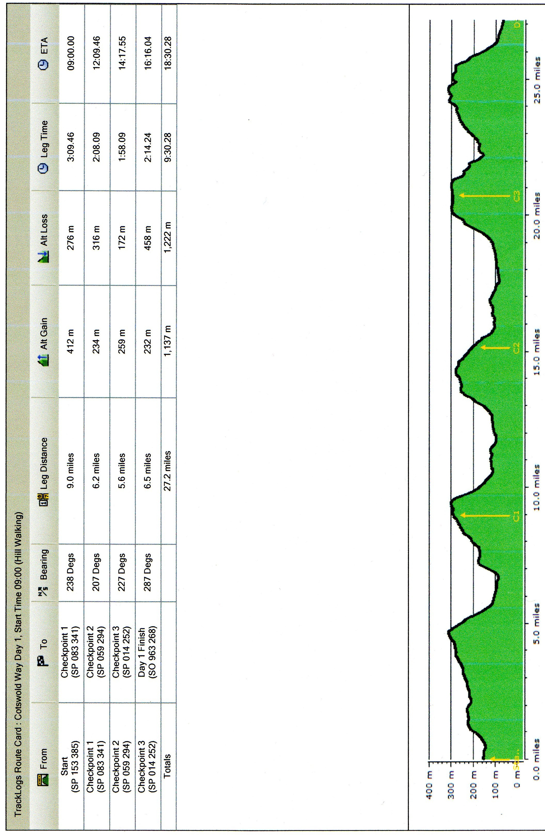
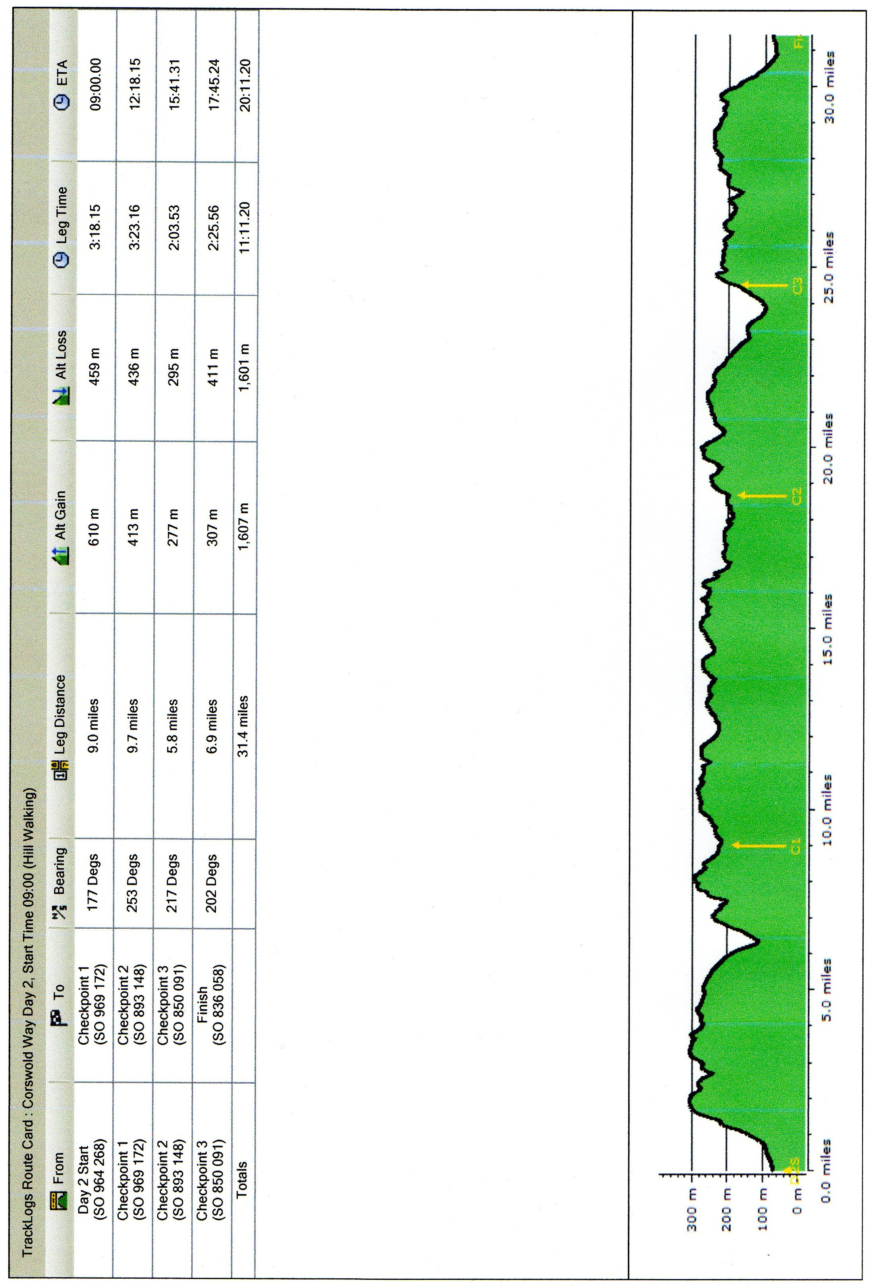

Checkpoint Food

Water, squash.
Small snacks, sweet and savoury (Marmite, sausage rolls, chocolate biscuits, malt loaf)
Sweets, crisps, pretzels.

Safety on the Course
The following information is important. Please read it carefully. This information will also be covered in the compulsory briefing prior to the event.

Kit Required

- The list below is a list of recommended, not compulsory, equipment to be taken. The only compulsory kit is a mobile phone with full battery and switched on to ring not silent.
- If weather dictates the Race Director may make some other equipment also compulsory.
- For your overnight kit please bring what you need to be comfortable and at minimum the kit on the list below in a reasonable size overnight bag.

Kit List

Running.
Running shoes or walking boots Running gear
Thermal top
Warm hat
Whistle
Rucksack
Water bottles or bladder
Emergency silver blanket
Mobile phone fully charged
Head torch and spare batteries (absolutely vital)
Long trousers / leggings

Overnight.
Sleeping bag.
Sleeping mat.
Comfortable clothing for the evening.
Wash kit including towel.
Ear plugs.
Eye covers.
Book / iPod for relaxation.
Mobile phone/GPS watch charger.
A few quid for refreshments and snacks.
Change of running clothing for each days running.
Blister plasters / iodine / antiseptic – foot care kit.

Route Hazards

- The ground maybe slippery so please be careful.
- Be aware and take caution crossing all roads – some are busy. Non are marshalled
- Be aware of other path users especially where it is narrow, dogs off the lead, horses, mountain bikes, walkers are all potential hazards.
- Caution with roots, rocks, steps, stiles that may be hidden or slippery

Medical
- Our paramedics will be on hand all weekend to assist with serious or minor injuries.
- Any incidents will be dealt with as part of our medical emergency procedures.
- It is important that you check the medical page of the website to ensure you have understood the potential medical risks of running these extreme distances.
- It is also important that you let the organisers know in advance of any medical problems that you know about and may be relevant to the race.

Actions On
Injury

- Try to get to a Checkpoint, where we will be able to recover you or treat you.
- Get to a recognisable location where you can report your position and call the race director to be recovered. (number on the route card)
- Tell another competitor where you are and ask them to inform the next CP, we will then plan your recovery

Our paramedic team will be on the course and at the finish and will manage all situations that need treatment. XNRG Medic – 07788864198
Serious Emergency (i.e. someone is knocked down) ring 999 first, then ring the XNRG Medic
Medical Emergencies will be taken to A & E

Lost
- Keep eyes on the National Trail signs.
- Use the route card and map.
- Look for fellow competitors behind or in front.
- Retrace steps to last known location.
- Ask a local walker/runner for help.
- If still lost, try to get to a road or town, ask at a pub or shop to help locate on the map.
- Or find a road with a name, a town and ring the race director, (number on the route card), to help guide you in.

Withdrawal
Only withdraw at a checkpoint and ensure the CP staff have been told you are withdrawing. We will get you to the finish when the CP closes.

Missing Checkpoint Time

- Checkpoint open and close times are on the route card.
- If you are too fast, or start in the wrong start and the CP is not set up, then you will need to decide whether you keep going or wait.
- If you are too late for a CP, we will keep it open till you arrive; if you are late for 2 CPs we may ask you to withdraw for the day and save your energy for the next day.

Dark

Head torches must be worn once it is dark, anyone arriving at a CP in the dark without a head torch will be pulled out.

